SQUARE INTERNAL TUBE INSERT 38MM×38MM 1 – 2.5MM
CODE NUMBER: P3838B 1 – 2.5MM

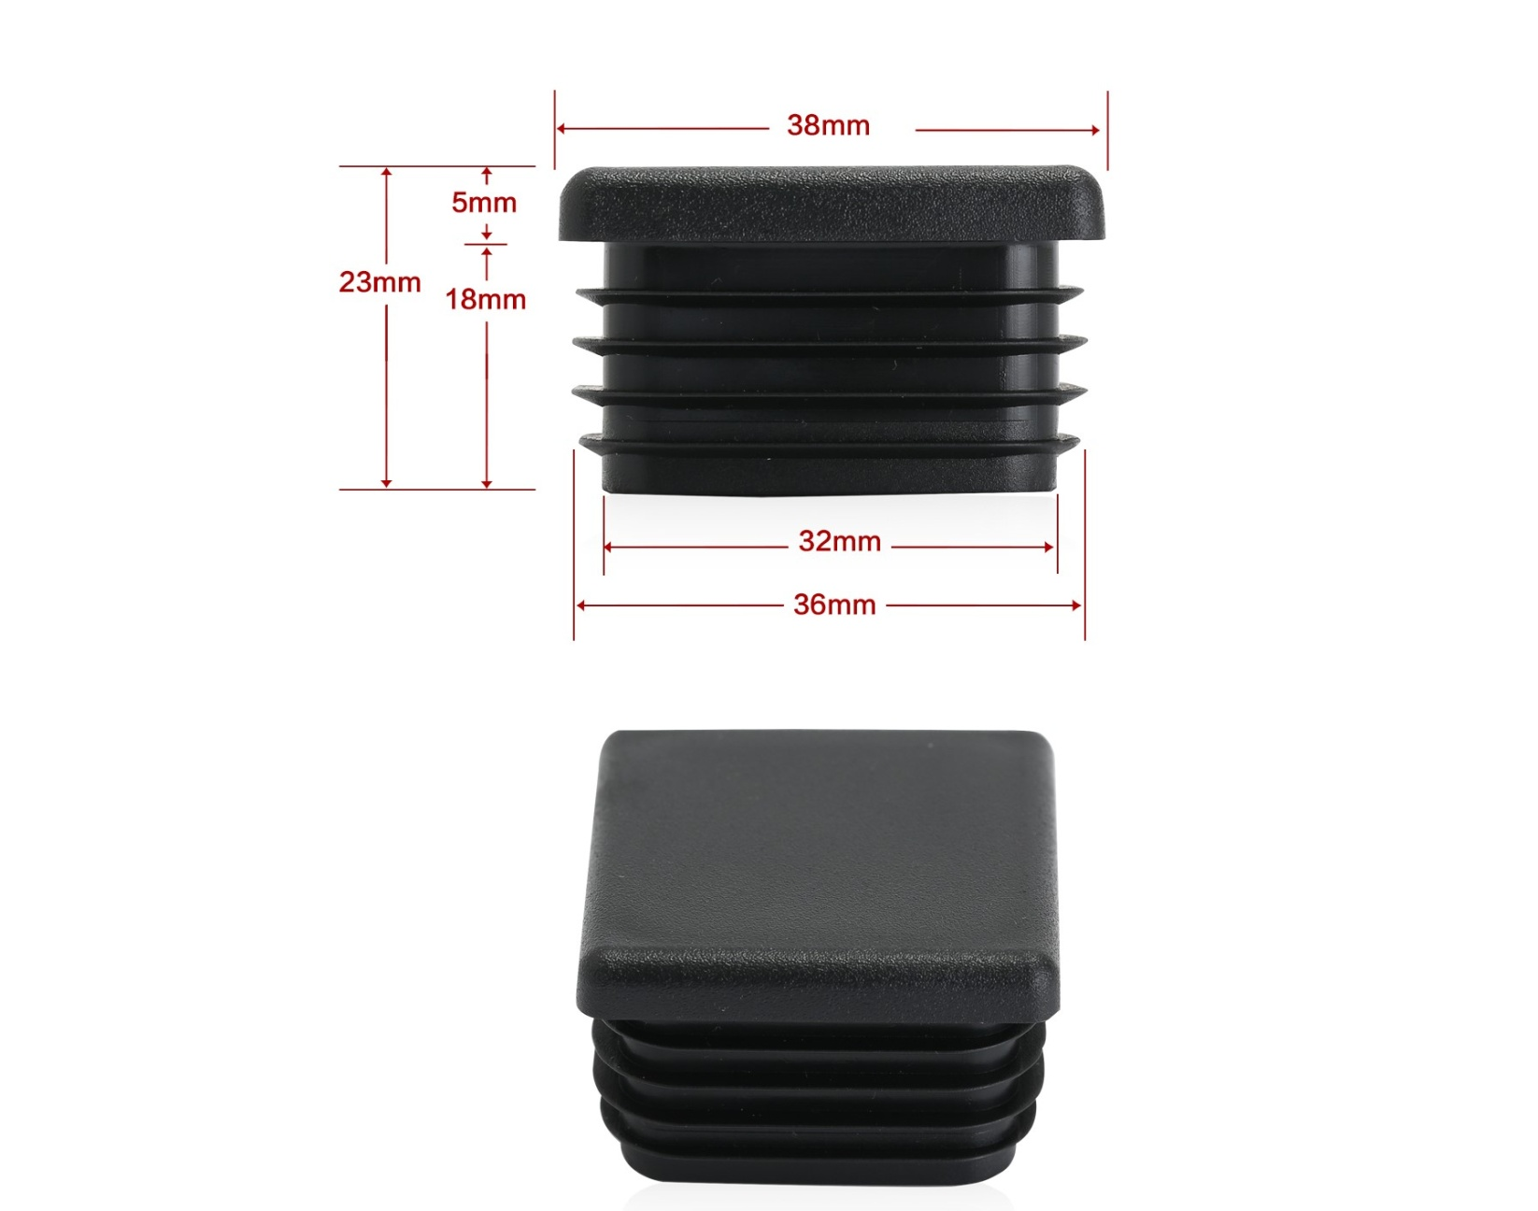

FITS: 38MM×38MM TUBE 1 – 2.5MM WALL THICKNESS
MATERIAL: POLYETHYLENE
STOCK ITEM COLOURS BLACK
COLOURS AVAILABLE ON REQUEST
PROUDLY MADE IN AUSTRALIA

